The Air Action Canvas

Context and Concept:

India’s worsening air quality poses a serious and growing threat to public health and the economy. 13 of the world’s 20 most air polluted cities are in India, with Delhi the most polluted capital, and approximately 3% of our GDP is lost annually due to air-pollution related events.

With pollution sources, population exposure, and resilience capacities varying across regions, there is an urgent need for place-based solutions that can tailor interventions based on local needs. For air quality solutions to be effective, the citizens must act as the solution owners, as they are the ultimate stakeholders (being directly affected by air pollution on a daily basis, and also uniquely positioned to drive their own behaviour change as well as demand accountability from the government at scale). Data is the critical enabler that makes this possible by ensuring that key information is in the hands of the citizens. The core hypothesis is that for air quality efforts to drive real impact, data must be accessible to citizens in forms that enable both individual and collective action

Local citizen action therefore requires a strong and coordinated upstream segment of the air quality value chain- beginning with data generation and extending up to citizen engagement with data. To unpack this upstream action, there are a flow of questions that need to be answered:
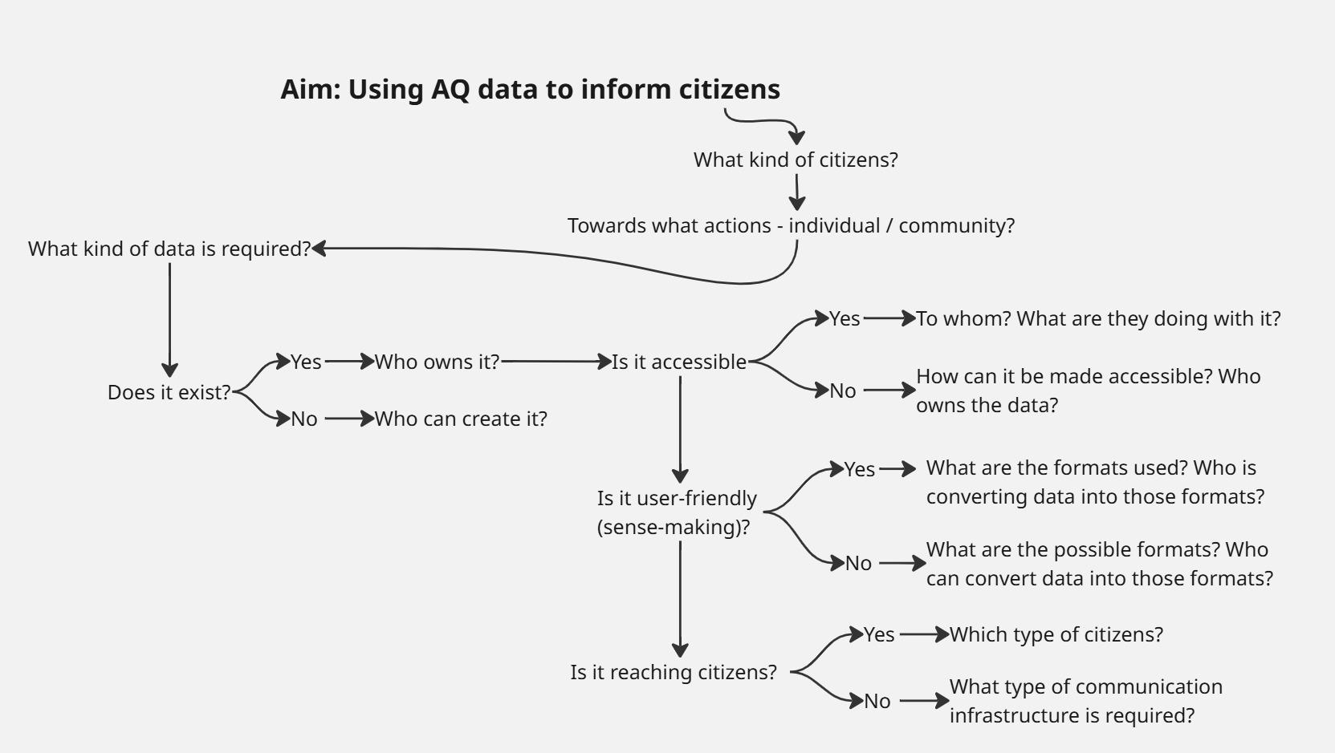

The Air Action Canvas was developed as a strategic exercise to answer these questions by mapping key actors, identifying gaps, and surfacing opportunities for collaboration.
Drawing on both secondary research and primary consultations with stakeholders, the canvas outlines
- who the critical players are at each stage of the upstream value chain,
- what types of data exist,
- how that data is formatted and used,
- and what structures govern its accessibility and application.
Accompanying the canvas is a directory of stakeholders, offering a deeper understanding of each actor’s specific role- intended to support more informed, collective action moving forward.
Definitions of Types of Data Represented in the Canvas

- AQ Data: Referring to real-time data on air quality, captured both through automatic as well as manual monitoring stations.This includes pollutants like PM2.5, PM10, NO₂, SO₂, CO, etc., and is typically used to understand current air quality levels.
- Historical Data: Archived air quality data collected over a period of time, enabling trend analysis, seasonal comparisons, and long-term exposure assessments.It is critical for research, policy planning, and evaluating the effectiveness of interventions.
- Forecasting Data:Predictive air quality data generated through models that combine historical trends, meteorological inputs, and emissions data to estimate future air quality levels.Used for early warning systems, public health advisories, and policy preparedness including pollution controls.
- Activity Data: Data related to activities that contribute to air pollution, such as vehicular traffic, construction, biomass burning, and industrial emissions.This data helps link pollution levels to specific sources and informs targeted mitigation strategies.
Key Gap Findings:

- Urban-Metro Concentration in Data Infrastructure:
  - Real-time, historical, and forecasting air quality data are primarily generated for urban areas, with a strong bias toward metro cities. While there are emerging shifts-for instance, forecasting efforts now include cities like Patna and Jaipur-the broader infrastructure remains heavily metro-centric.
  - Even within cities, the deployment of low-cost sensors is limited, missing opportunities to install them in residential welfare associations (RWAs) or in areas inhabited by more vulnerable populations.
- Need for Data Storing Beyond Government Servers:
  - It is crucial for more air quality data to be stored and maintained by non-government institutions. Government-controlled data can be withdrawn from public access without notice- as seen when the Central Electricity Authority removed historical emissions data from coal-based power plants. Ensuring backup repositories in independent institutions can protect data availability over time.
- Limited Accessibility to Raw Data Across Types:
  - For real-time AQ data, there needs to be more accessibility to data collected by low cost sensors.
  - Historical air quality data is usually available only through inconsistent summaries at various intervals by different states, or through formal requests or partnerships.
  - Forecasting and activity data are shared in limited, simplified ways, but the detailed raw information needed for deeper use or model replication is rarely made openly available.
- Gaps in Standardized, Open Sense-Making Tools:
  - Many organisations are becoming involved in interpreting air quality and related data, but the tools and methods they use are rarely open or standardized, making it hard for others to build on this work or apply it locally.
  - Just like data creation, data sense-making remains mostly concentrated in urban areas.
- Limited Communication Pipelines and Language Barriers:
  - Communication of interpreted data mirrors the urban focus seen in data creation and interpretation. Activity data is communicated only by a few creators to limited audiences, whether in urban or rural areas.
  - Historical and forecasting data are communicated more to government stakeholders than to the broader public.
  - While some platforms are working to increase reach through infographics and dashboards, there remains a critical need for more communication in local languages and formats accessible to diverse communities.
- Citizen Engagement is the Weakest Link:
  - Citizen training and support for engaging with air quality data is the most underdeveloped area. While there are some localized efforts to train communities on real-time or activity-linked data, there are virtually no structured formats or meaningful examples to help citizens understand or act on historical or forecasting data, leaving a major gap in public participation and informed decision-making.
  - It is critical to have on-going sessions rather than one-off workshops to ensure that the citizens are truly empowered to use data for behaviour change and demanding public accountability.
Emerging Hypothesis:
Strengthening air quality action in India requires bridging the gap between data availability and data usability at the community level. While urban areas have some infrastructure for real-time air quality monitoring, the data often remains disconnected from the people most impacted. Embedding monitoring infrastructure within Resident Welfare Associations (RWAs), combined with structured, ongoing training and support, could create a new layer of local data ownership, public awareness, and action.

Proposed Pilot as Proof of Concept
A year-long collaborative pilot that sets up air quality monitors in selected RWAs across one city, paired with monthly training sessions, localized data dashboards, and facilitated public-private dialogues, can serve as a proof of concept to test the following:
- Can hyperlocal data, when made accessible and understandable, mobilize collective citizen action (e.g., pushing for traffic control, regulating construction dust, reducing chulha burning)?
- Will citizens use the data for individual behavior change (e.g., adjusting exercise routines, using masks or air purifiers)?
- Can this engagement unlock more responsive local governance and institutional accountability?
- What types of tools, formats, and facilitation are most effective in enabling sense-making and sustained participation?
This pilot will require raw data creators to install monitors (such as Aurassure, CSTEP), which should then be stored in reliable and open platforms (for instance by stakeholders like Tarkam), and translated into simplified, locally relevant insights in local languages and visuals (for instance by stakeholders like Envirocatalysts, Urban Emissions) . Finally, citizen training and engagement actors (with Samaaj Data, Asar mobilising citizens, and other stakeholders in the upstream being the resource organisations) must build community capacity to interpret and act on this information, feeding back into insights created by data translators.
This essentially means that coordination is required across the value chain for the pilot to be successful, which is where Dasra (as ClimateRISE Alliance’s Secretariat) will play a key role of orchestrating partnerships, enabling cross-learning, and strategic alignment. It will act as the Project Management Unit (PMU) responsible for driving implementation, monitoring progress, facilitating stakeholder coordination, and ensuring that the pilot stays on track to achieve its intended outcomes.
Ecosystem Level Intervention
While the place-based pilot is important for laying the foundation of a replicable, citizen-facing information ecosystem in air quality, it is equally critical to work at the wider ecosystem level in parallel. This ensures that insights and innovations from the pilot can inform action in other geographies. It also helps embed data and knowledge sharing as a core part of air quality action.
For this- two types of intervention are proposed, one that is digital platform based, and one that is convening based.
The digital intervention involves developing an open-access platform where data creators and analysts can upload, access, and share information in a standardized format. This would serve as a common repository, improving transparency, comparability, and usability of air quality data.
An important point to note is that open-source initiatives often perform well initially, but over time, support tends to diminish- typically due to cost-benefit considerations related to organizational resources (i.e., organisations may perceive the benefit of the platform not adding up to the amount of resources they are putting in to maintaining the platform). One way is to financially compensate the organisations, but a more sustainable approach is to ensure that the repository becomes the most credible one-stop repository for air data in India (so that everyone automatically sees the value-add in being associated with the project),which in turn requires strategic communication around the repository. For instance, the focus should be on positioning the platform as unique by connecting air quality data with activity data and stories, ensuring rich visualization and storytelling that attracts diverse users.
The convening-based intervention focuses on creating a regular dialogue space around upstream air quality action. These convenings will help surface insights from the pilot, facilitate ongoing knowledge exchange, and strengthen collaboration to inform future pilots or scale successful models in new geographies.
In both interventions, Dasra will play a facilitative and enabling role. For the digital platform, Dasra will ensure the necessary coordination required to put together such a repository. For the convening-based intervention, it will anchor regular multi-stakeholder dialogues, curate insights, and drive collective agenda-setting for upstream air quality action.

